Pumpkin Patch
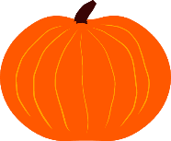
- Pumpkin patch, Pumpkin patch,

- Looking for a pumpkin in a pumpkin patch

- See it here, Nice and fat

- Turn into a Jack o’ Lantern just like that

